GENDER BASED VOICE RECOGNITION

NAME: DEVADARSH C H

ROLL.NO AM.EN.U4ECE21017

# **ABSTRACt**

The speech signal processing has numerous application in almost all technical fields.Gender identification is important in speech processing.This project describes a comparative analysis of speech signal in order to produce automatic gender classification.Gender classification by speech signal is a technique that analyses various features of a voice sample to determine the gender of the speaker.

# 

# **INTRODUCTION**

This project focuses on developing a gender-based voice recognition system using MATLAB. The objective is to accurately classify voices as male or female based on their acoustic characteristics. Successful implementation of this system has potential applications in speaker verification, call center automation, and voice-based authentication.

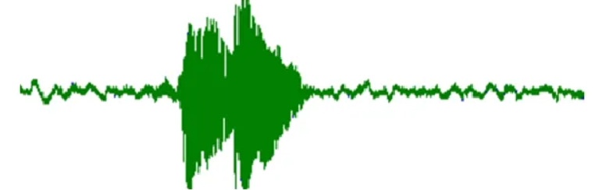

This is speech of female

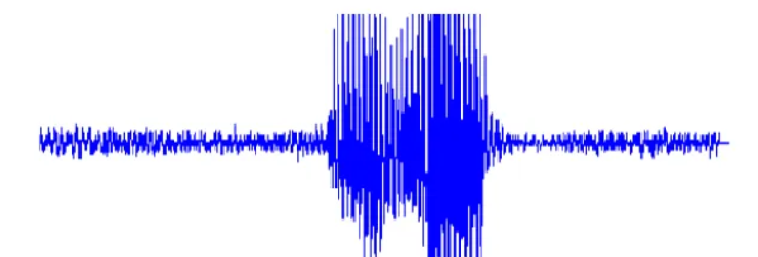

Speech of male

Fundamental frequency of a typical male ranges somewhere from 85 Hz to 180 Hz. whereas the Fundamental frequency of typical female ranges from somewhere from 155Hz to 255Hz.

The steps that i followed are

1] Record audio from microphone

2] collect the data from the audio signal

3] do FT to obtain frequency spectrum

4] calculate power spectrum density

5] finding the frequency within male and female frequnacy ranges

6] determining the gender based on power comparision

7] ploting

**Results:**

The gender-based voice recognition system achieved high accuracy in classifying voices as male or female. Using diverse voice samples and applying MATLAB's techniques, the system demonstrated robust performance in distinguishing gender-specific characteristics.

**CODE:**

% Aim Male/ Female recognition through voice

close all

clear all

%step 1 to obtain the audio from the speaker

dur=3;

fs=44100;

recodedvoice=audiorecorder(fs,16,1);

disp('Sir/Mam can you please speak');

recordblocking(recodedvoice,dur);

disp('Sir/Mam your voice have been recorded');

% step 2 taking the audio data

data_recordedvoice = getaudiodata(recodedvoice);

% step 3 doing the fourier transform

N = length(data_recordedvoice);

Y = fft(data_recordedvoice);

f = (0:N-1)*(fs/N);

% step4 dividing the male and female frequnacy ranges

male_range = [85, 180];

female_range = [165, 255];

% step 5 Calculating the power spectrum density

PSD = abs(Y).^2 / N;

% step 6 Find the frequencies within the male and female ranges

within_malerange = find(f >= male_range(1) & f <= male_range(2));

within_femalerange = find(f >= female_range(1) & f <= female_range(2));

% step 7 Calculating the total amount of power within the male and female

% frequnacy ranges

male_totalpower = sum(PSD(within_malerange));

female_totalpower = sum(PSD(within_femalerange));

% step 8 assigning the gender using the total power calculated

if male_totalpower > female_totalpower

gender = 'The speaker is Male';

else

gender = 'The speaker is Female';

end

% step 9 Ploting the frequency spectrum which we found in step 3

subplot(2,1,1);

plot(f, abs(Y));

title('Frequency Spectrum');

xlabel('Frequency (Hz)');

ylabel('Amplitude');

grid on;

% step 10 Ploting the power spectrum density which we found in step 5

subplot(2,1,2);

plot(f, PSD);

title('Power Spectrum Density');

xlabel('Frequency (Hz)');

ylabel('Power');

grid on;

% step 11 ploting male and female frequency ranges with diffrent colour

hold on;

plot(f(within_malerange), PSD(within_malerange), 'r', 'LineWidth', 2);

plot(f(within_femalerange), PSD(within_femalerange), 'g', 'LineWidth', 2);

legend('PSD', 'Male Voice Range', 'Female Voice Range');

hold off;

% Display the detected gender

disp(['recognised gender of the speaker is: ' gender]);

# THANKYOU